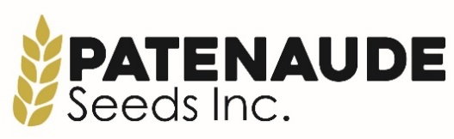

ADMINISTRATIVE ASSISTANT POSITION
Patenaude Seeds Inc. is a family run business near Holland, Manitoba. We are looking to add an experienced and detailed oriented part time/casual administrative assistant to work with our team.
Proficiency in Microsoft 365 as well as related programs (Word, Excel, Teams), and basic accounting knowledge is required. Demonstrating a keen ability to learn new programs and take part in on-the-job training is an asset along with experience on social media platforms and website upkeep. The successful candidate for this position must be willing to work alone or with a group, be highly motivated and organized, patient, self driven, and able to handle multiple tasks simultaneously. Agriculture background is an asset but not required.
Duties:
- secretarial and reception duties
- day to day accounting
- data entry; create and develop spreadsheets for inventory
- scanning, copying, and organizing files
- maintain daily, monthly, annual logs and checklists
- order and track supplies
- post to websites and social media
- prepare orders for bagging and toting (work orders, tags, pallet sheets, etc.)
- assist with booking and coordinating trucking and associated paperwork
- occasional pickups and drop offs of supplies/and or materials, parts, and coworkers
Requirements
- Proficient in Microsoft Office and Microsoft 365
- Basic accounting experience (AgExpert software knowledge an asset)
- Attention to detail
- Experience with social media platforms
- Friendly and energetic
- Driver’s license
- Flexible schedule
Benefits
- Health package – shared cost with employer available
- Casual dress code (appropriate to surroundings)
- Flexible hours on a week-to-week basis
Wages
- Hourly wage to be determined depending on experience
- Flexible schedule
- Monday-Friday hours to be determined by our need and the availability of successful candidate

Application deadline – July 28, 2025; Start date – August 18, 2025 or sooner
How to apply: Please send resume and 3 references to patenaudeseeds@outlook.com

